Advanced Image Processing

Midterm Examination

Student No.: 　　　　　　　 Name:　　　　　 109/11

1. 是非題(T/F test) (25%)

( T )1. The main trouble with the pinhole model is that the projective transformation sees a small object close to the camera in the same way as a big object remote from the camera. It means that the pinhole model of imaging geometry does not distinguish size of objects.

( T )2. The transition between continuous values of the image function (brightness) and its digital equivalent is called quantization.

( T )3. A continuous image is digitized at sampling points. These sampling points are ordered in the plane, and their geometric relation is called the grid.

( T )4. The relation ‘to be contiguous (鄰近的)’ is reflexive, symmetric, and transitive.

( F )5. Edge is a global property of a pixel and its neighborhood. It is a vector given by a magnitude and direction which tell us how fast the image intensity varies in a small neighborhood of a pixel.

( F )6. Topological properties are variant to homeomorphic transforms.

( T )7. Impulse noise means that an image is corrupted with individual noisy pixels whose brightness differs significantly from that of the neighborhood. One example is the salt-and-pepper noise.

( T )8. The entropy can serve as a measure of ‘disorder’. As the level of disorder rises, entropy increases and events are less predictable.

( F )9. The body reflection rebounds (反彈) incoming energy in a similar way to a mirror. The spectrum of the reflected light remains the same as that of the illuminant and it is independent of the surface.

( T )10.Colors can be represented as combinations of the primary colors. Primary colors include red, green and blue.

( T )11. Retina (視網膜) is composed of photoreceptors (感光器). There are two types of photoreceptors: rods and cones.

( T )12. Perceived properties help people to connect elements together (in cluttered scenes) based on strongly perceived properties as parallelism, symmetry, continuity and closure.

( T )13. Signal-to-noise ratio (SNR) represents a measure of image quality, with high values being ‘good’.

( T ) 14. Let *f*, *h* be functions and *F*, *H* be their corresponding Fourier transform results respectively, then convolution () and its Fourier transform can be related by  
 (*f* * *h*)(*x, y*) = *F*(*u, v*)*H*(*u, v*).

( T )15. Let *f* be a function and *F* be its corresponding Fourier transform result. The value of   
*f* (0) is the area under the frequency spectrum *F*(ξ).

( F )16. Convolution is a non-linear operation for image analysis.

( F ) 17. Given primary colors *R*, *G*, *B*, then color matching functions can be obtained by ; where should be negative.

( F )18. Color sensitive receptors on the human retina are rods. Rods are categorized into three types based on the sensed wavelength range, approximately corresponding to red, green and blue.

( F ) 19. A function is odd symmetric function if , sine function is an even symmetric function.

( T )20. If an image function has the property then its corresponding Fourier transform is a real function.

( T ) 21. The sample interval should be chosen such that it is less than half of the smallest interesting detail in the image.

( T ) 22. The sample interval should be chosen such that it is less than half of the smallest interesting detail in the image.

( F ) 23. In the short time Fourier transform, the signal is divided into small windows and treated locally as it were periodic. A wide window yields poor frequency resolution and a narrow window provides poor localization.

( F ) 24. Histogram and co-occurrence matrix are both examples of local information.

( F ) 25. Consider a discrete 1D signal *s* of length *N* which has to be decomposed into wavelet coefficients *c*. The fast wavelet transform developed by Mallat (1989) consists of steps at most.

1. 簡答題(Short description question)
2. (2%) Which color has the smallest hue value (色度值) ? (a) yellow (b) blue (c) cyan (d) green  
   ANS: ( a )
3. (2%) If a color pixel whose RGB values are (0, 0, 255), what is its corresponding saturation values in HSV color model? (Note that we assume that the saturation value is in [0, 255])  
   (a) 0 (b) 85 (c) 127 (d) 255

ANS: ( d )

1. (2%) The following RGB values represent the colors of four pixels in RGB model respectively. Which one has the largest value V in the HSV model? (a) (200, 20, 0) (b) (155, 155, 155) (c) (0, 250, 10) (d) (200, 220, 0)  
   ANS: ( b )
2. (2%) A stage of the wavelet transform will generate four output images, including approximation, horizontal detail, diagonal detail, and vertical detail. Which one is the HH(rows high-pass and columns high-pass) image? ANS: ( D )

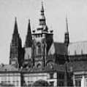 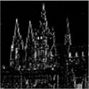 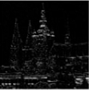 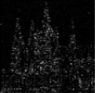

(A) (B) (C) (D)

1. (5%)Given the following functions , please draw their corresponding Fourier transform results .

 

------------------------------------------------------------------------------------------------------------------

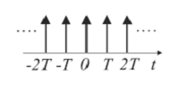 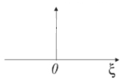

FT

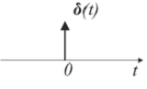 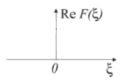

FT

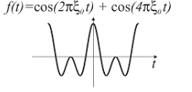 

FT

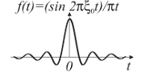 

FT

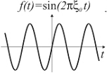 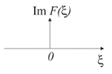

FT

1. (2%) Given Harr wavelet function, please draw the corresponding graphs of .

, ,

where



1. (2%) The quality of a digital image grows in proportion to the spatial, spectral, radiometric(輻射的) and time resolutions. Can you explain what is time resolution?

The time taken by the lens to capture images within a specific time period

1. (2%) Any function *D* holding the following three conditions is a distance (or a metric): identity, symmetry, and triangular inequality. What is the triangular inequality condition?

The sum of two sides of a triangle is greater then third side triangle

1. (2%) What is 2D Dirac delta function ?
2. (4%) Given a 1D function , please show its corresponding even part and odd part.

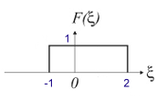

1. (4%) In the following image, the pixels corresponding to the subset (object) have been set to 0. Please finish its chamfering distance image by using the city block distance.

|  |  |  |  |  |  |  |  |  |  |
| --- | --- | --- | --- | --- | --- | --- | --- | --- | --- |
| 0 |  |  |  |  |  |  |  |  | 0 |
| 0 |  |  |  |  |  |  |  |  |  |
| 0 |  |  |  |  |  |  |  |  |  |
| 0 |  |  |  |  |  |  |  |  |  |
| 0 |  |  |  |  |  |  |  |  |  |
| 0 |  |  |  |  |  |  |  |  |  |
| 0 |  |  |  |  |  |  |  |  | 0 |

1. (2%) Let *f*, *g*, *h* be functions and *a* be a scalar constant. Which properties are satisfied by the convolution operator ()?

(A)  (B) 

1. (*a f* )*(*a g*) = *a*( *f* * *g*) (D) 

ANS: ( A,B )

1. (4%) Given an image and a mask , please show the convolution result of and . The convolution of and , denoted as , is given by , where and .

|  |  |  |  |  |
| --- | --- | --- | --- | --- |
| 0 | 0 | 0 | 0 | 0 |
| 0 | 0 | 0 | 0 | 0 |
| 0 | 1 | 1 | 0 | 0 |
| 0 | 0 | 2 | 0 | 0 |
| 0 | 0 | 0 | 0 | 0 |
| 0 | 0 | 0 | 0 | 0 |

|  |  |  |
| --- | --- | --- |
| 1 | 2 | 3 |
| 4 | 5 | 6 |
| 7 | 8 | 9 |

**Convolution result**

|  |  |  |  |  |
| --- | --- | --- | --- | --- |
|  |  |  |  |  |
|  |  |  |  |  |
|  |  |  |  |  |
|  |  |  |  |  |
|  |  |  |  |  |
|  |  |  |  |  |

1. (3%) Given a graph as below, if the reference point starting the chain is marked by an arrow please write down its chain codes.

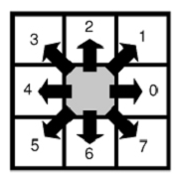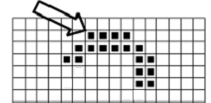

Answer-00077664223444541

1. (2%) Which ones are band-limited signals? ANS: ( A,D )

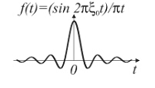 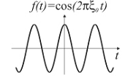 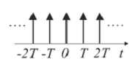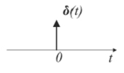

(A) (B) (C) (D)

1. (3%) Run length coding has been used to represent strings of symbols in an image matrix. Run length coding records only areas that belong to objects in the image. Given a graph as below, please show its codes.

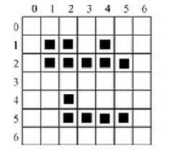

1. (4%) Please show the corresponding Fourier transform results of the following figures.

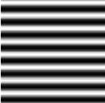 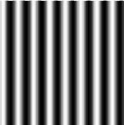 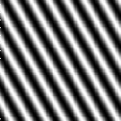 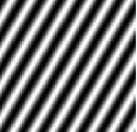

ANS: ( a ) ( b ) ( c ) ( d )

1. 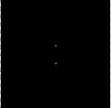 (b) 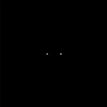 (c) 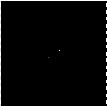 (d) 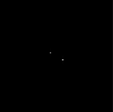
2. (2%) Applying different distance functions in chamfering distance transformation algorithm will obtain different output image. Which one can be obtained by using chessboard distance function?

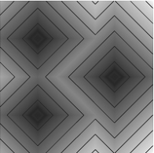 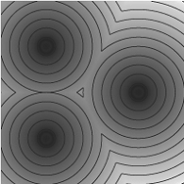 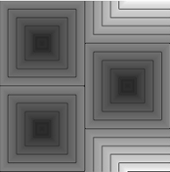

1. (b) (c)

ANS: ( c )

1. (2%) Which one is the corresponding Fourier transform result of the following figure A?  
   ANS: ( D )

 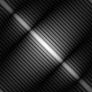 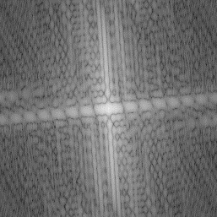 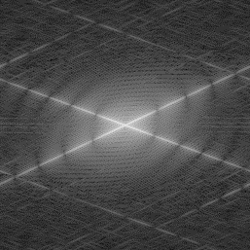 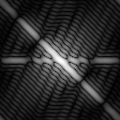

Figure A (A) (B) (C) (D)

1. (2%) Let and be the corresponding 2D Fourier transform results of and , respectively. It means that and . Moreover, ‘*’ is convolution operation. Which one of the properties of 2D Fourier transform is **incorrect**?

(A)

(B)

(C) If is real-valued and , then is a real function.

ANS: ( B )

1. (2%) Please fill in the blanks in Algorithm 2.3 to generate Gaussian noises.

**Algorithm 2.3: Generation of additive, zero mean Gaussian noise**

Step1: Suppose an image has gray-level range .

Select ; (low) values generate less noise.

Step 2: For each pair of horizontally neighboring pixels , generate a pair of independent random number in the range .

Step 3: Calculate

Step 4: Set and , where is the input image.

Step 5: Set

;

Step 6: Go to Step 2 until all pixels have been scanned .

1. (4%) Let low pass filtering be defined as averaging and high pass filtering is defined as differencing. Here shows a simple example of Wavelet transforms.

Input data: *a*, *b*

Average: *s* = (*a* + *b*) / 2 (low pass filtering)

Difference: *d* = *a* – *s* (high pass filtering)

Wavelet coefficients: (*s*, *d*).

Suppose the input vector is *v* = [38 74 12 56]. Please show the wavelet coefficients of level 1, *v*1, and wavelet coefficients of level 2, *v*2.

1. (4%) Please fill in the blanks in Algorithm 4.2 to construct integral images.

**Algorithm 4.2 Integral image construction**

1. Let  denote a cumulative row sum, and set 

2. Let  be an integral image, and set 

3. Make a single row-by-row pass through the image.

For each pixel  calculate the cumulative row sums    
and the integral image value 

= s(i,j-1) + f(i,j)

= ii(i-1,j)+s(i,j)

4. After completing a single pass through the image, the integral image  is constructed.

1. (2%) Please show the corresponding integral image of the following image.

**Input image Integral image**

|  |  |  |  |  |  |  |  |  |  |  |
| --- | --- | --- | --- | --- | --- | --- | --- | --- | --- | --- |
| 1 | 2 | 2 | 4 | 1 |  |  |  |  |  |  |
| 3 | 4 | 1 | 5 | 2 |  |  |  |  |  |  |
| 2 | 3 | 3 | 2 | 4 |  |  |  |  |  |  |
| 4 | 1 | 5 | 4 | 6 |  |  |  |  |  |  |
| 6 | 3 | 2 | 1 | 3 |  |  |  |  |  |  |

1. (5%) If the relation *r* is *to be a southern or eastern 4-neighbor of the pixel, or identity*, using algorithm 4.1, please show the corresponding co-occurrence matrix of the input image.

**Algorithm 4.1 Co-occurrence matrix  for the relation .**

1. Set  for all , where  is the maximum brightness.

2. For all pixels  in the image, determine all  which have the relation  with the pixel , and perform .

**Input image**

|  |  |  |  |  |
| --- | --- | --- | --- | --- |
| 2 | 2 | 2 | 2 | 2 |
| 2 | 1 | 1 | 1 | 2 |
| 2 | 1 | 0 | 1 | 2 |
| 2 | 1 | 0 | 1 | 2 |
| 2 | 1 | 1 | 1 | 2 |
| 1 | 2 | 2 | 2 | 1 |

**Co-occurrence matrix**

|  |  |  |  |
| --- | --- | --- | --- |
|  | 0 | 1 | 2 |
| 0 | 2 | 2 | 0 |
| 1 | 2 | 10 | 7 |
| 2 | 0 | 9 | 8 |

1. (5%) Can you explain the meaning of the following figure? (Please list at least 5 key points)

